|  |  |
| --- | --- |
| **Maynooth University**  Maynooth, Co. Kildare, Ireland  **Ollscoil mhá nuad**  maigh nuad, co chill dara, éire  **School of Modern Languages, Literatures and Cultures**  Scoil na Nua-Theangacha, na Litríochtaí agus na gCultúr |  |

Maynooth University SMLLC

Cover page for submission of essays / projects / assignments

This coversheet must accompany ALL assignments submitted

**Student Name:** Samuel Joseph Mc Donnell

**Student Number:** 22252963

**Word Count:** 8020

**Title of Essay/Assignment:** “An Extreme Analysis and Temporal Clustering of Sea Level Surge Exceedances Around the Irish Coastline.”

**Course Code:** MHR64  
**Module Code:** ST606[A]  
**Lecturer/Tutor:** Dr. Niamh Cahill  
**Due Date:** 9th August 2024  
**Declaration by student:**

I am aware of what **plagiarism** is and hereby confirm that no part of this assignment is plagiarised.

**Signed:** Samuel McDonnell

***(electronic signatures are acceptable / printed coversheet signed and scanned for inclusion with assignment)***

**Date:** 7th August 2024

**Table of Contents**

**1. Introduction** 3

**1.1 Background** 3

**1.2 Objectives** 4

**2. Data** 5

**2.1 Data Sources** 5

**Methodology of Data Collection** 5

**2.3 Exploratory Data Analysis** 6

**Summaries and** **Visualisation** 7

**Model Implementation** 11

**3. Methods** 11

**4. Results** 12

**Block Maxima Model Fitting** 12

**Block Maxima Results** 14

**Peaks-Over-Threshold (POT) Model Fitting** 19

**Peaks-Over-Threshold Results** 20

**5. Discussion** 26

**Higher Return Levels with the POT Method** 28

**Interpretation of Results** 28

**6. Conclusion** 29

**Summary of Objectives** 29

**Return Levels** 29

**BM Focus on Annual Extremes** 30

**Practical Implications** 30

**Limitations** 30

**Recommendations** 30

**Final Thoughts** 30

**7. References** 31

**9. Appendices** 33

**Information on Supplementary Code** 33

**Supplementary Tables** 34

*An Extreme Analysis and Temporal Clustering of Sea Level Surge Exceedances Around the Irish Coastline.*

# **1. Introduction**

## **1.1 Background**

The Irish Coastline stretches approximately 7,400 kilometres long and it is estimated that 40% of the Irish population live within 5 kilometres of the coastline (Climate Ireland, CSO Census 2016). This presents a massive risk to communities in coastal areas. Heavy flooding is affecting Irish communities on a near-annual basis. Coastal erosion threatens shorelines, habitats and ecosystems(ICPSS, 2020). These risk factors contribute to infrastructural, agricultural and ecological damage, which likely averages to greater than €50 million per year in economic costs (Environmental Protection Agency, 2021).

Surprisingly, relatively limited analysis has been done on extreme sea level surges at a national level, despite lots of work being done on flooding more generally. There are some possible reasons for this. There could be a perception of lower risk by comparison to other countries, leading to underinvestment in the area. Ireland’s population centres can be prone to riverine flooding and heavy rainfall, potentially diverting attention from coastal surges. The tidal gauge coverage around Ireland is reasonable, however a short history of data over time also indicates difficulties for extremes analysis. There may also be institutional and policy gaps at play, as outlined in a 2023 report by the *Department of Housing, Local Government and Heritage*, many of Ireland’s coasts are fragmented in management by local authorities. This leads policy is lagging behind the growing understanding of climate impacts, leading to insufficient integration of storm surge analysis in planning and development guidelines.

Olbert et al. (2013) found that tide-surge interactions significantly affect total sea levels in Irish coastal waters. While their study incorporates tidal data, the insights gained from their analysis of surge events are directly applicable to this research on extreme sea level surges. For instance, their identification of surge components and their influence on extreme sea levels supports a focus on understanding and modelling these surges. McGrath et al, (2018) focused on the Irish Sea and the potential effects of climate change on extreme sea levels. Their work used numerical models to assess future sea level extremes and their implications for coastal areas in Ireland​. Another local analysis was done by Jones and Davies (2006) applying the TELEMAC finite element model to compute wind-induced responses in the Irish Sea. This study provides a detailed analysis of how wind and surge interactions affect total sea levels in this region​. Although further work on this topic should include tidal/wind data, this paper will provide a valuable context for interpreting the behaviour of extreme surge events.

Storm Ophelia in 2017 is considered to be the worst storm in Ireland in 50 years, and the easternmost Atlantic hurricane on record (Lui, 2017). The coastal damages from this storm alone amounted to about €68 million according to initial insurance industry estimates. This includes insured losses and the broader economic impact on businesses and infrastructure. Insurance companies faced €35 million for claims around damage to property, vehicle and assets. Agricultural losses amounted to €10 million in crop, livestock and farm infrastructure damage (Towey, 2018). Coastal areas faced heavy erosion and damage due to high waves and storm surges while beaches, dunes and coastal infrastructure were particularly affected (Ophelia Report, 2017). Storm Ophelia heightened awareness around the risks posed by severe weather events and the need for better preparation and resilience planning. Over time, specific storms will affect areas of the coast differently, but some areas will persistently be more vulnerable in the long term. This relates to one of the main objectives of this paper: identifying these relatively vulnerable areas.

In a broader context, Ireland is not alone in its heavy placement of location centres on the coastline. According to estimates by Rentschler et al. (2022) 1 billion people globally reside on land with a significant flood risk, and flooding is a near-universal threat, causing issues in all 188 countries in the study. Over the last century, high sea levels have posed significant risks resulting in the loss of over 8 thousand lives annually and disrupting/displacing approximately 1.5 million people each year on average (IPCC, 2021).

There is also serious economic impact to account for. Mean global flood losses for major coastal cities amount to ~$6 billion per year as of 2005, expected to increase to $52 billion by 2050 (Hallegatte et al. 2013). Projections by (IPCC, 2021) suggest that this cost may increase by 2-3 orders of magnitude annually by 2100, even with constant flood probability maintained through adaptations. Without adequate adaptation measures, up to 4.6% of the global population is expected to face annual flooding by 2100, with potential losses reaching 9.3% of global GDP (Hauer et al. 2019; IPCC, 2021). Infrastructure vulnerability is another concern, with coastal areas being at an elevated risk of disruptions to power supply cuts or transportation obstructions (McRobie et al. 2005). Furthermore, environmental risks include the erosion of sandy beaches and saltwater intrusion into agricultural land (Oppenheimer et al., 2019). The disruption of coastal habitats and biodiversity is a longer-term risk at play (Griggs and Reguero, 2021; Kearney and Fernandes, 2019).

Effective adaptation and management strategies can be determined by improving the understanding of the causes and related impacts of sea level extremes, including their role in coastal flooding and erosion. The specific contributions of this work will outline areas of vulnerability along the Irish coastline, as well as a brief indication of how they are vulnerable relative to each other, with some areas being subject to higher though less frequent extremes and vice versa. Return levels will be estimated using two methods of extreme analysis. The specifics of these vulnerabilities will be discussed and explained further in the coming sections.

## **1.2 Objectives**

This work focuses on characterising sea-level extremes using extreme value analysis. This type of analysis utilises extreme value distributions to characterise the tail ends, or extremes, of the overall data distribution. In addition, we consider temporal clustering of the exceedances of return levels calculated from the extreme models. The input data for the extreme models in this analysis is sea-level surge data, which strongly influence coastal flooding and erosion. Estimated return levels based on the data can then be extracted from the model. A return level is a threshold that a particular environmental variable, in this case sea-level surge, is expected to exceed once in a given period of time, such as once in 10, 50, or 100 years. It quantifies the magnitude of extreme events that are likely to occur over different time intervals. Here we focus on the 2-year, 5-year, 20-year, and 100-year return levels for the data, which can be more easily understood as the levels at which we could identify an event as a 1-in-2, 1-in-5, 1-in 20, or 1-in-100-year event.

Following the return level estimation, a plot of a temporal clustering of the exceedances of the 1-in-2 and 1-in-5 levels for each station in each year will highlight areas of the coast which face higher counts of spikes above return levels. The objective of clustering the return level exceedances is to identify areas of higher vulnerability, which may be more threatened more often by large spikes in sea level surges.

These extreme analysis objectives outlined above will be tested by two means. The first method will take a block maxima approach, which identifies extreme values as annual maxima for each location. This will use a Generalised Extreme Value (GEV) distribution. The second method is a Peaks-Over-Threshold approach, where any data above a 99th percentile threshold is classified as extreme data. This method used a Generalised Pareto Distribution (GPD). Based on the results of each method, an analysis of the types of vulnerabilities faced by each location relative to one another will then be composed.

# **2. Data**

## **2.1 Data Sources**

The sea surge data used in this analysis is sourced from the Copernicus Climate Change Service (C3S), specifically the dataset titled “Global Sea level change time series from 1950 to 2050 derived from reanalysis and high resolution CMIP6 climate projections.” This dataset provides a comprehensive time series dataset of global sea level-related variables including tides, storm surges and sea level rise. The data spans from 1950 to 2050, offering insights into historical trends and projections into the future. For this project we focus on the historical and ERA5 reanalysis data which spans from 1979-2014.

### **Methodology of Data Collection**

This dataset is generated using the Deltares Global Tide and Surge Model (GTSM) version 3.0. This hydrodynamic model simulates water levels at 10-minute intervals, then it forces input from both reanalysis data and climate models (Muis et al., 2020). Key methodologies included:

* Hydrodynamic Modelling: the GTSM dynamically simulate water levels. It integrates multiple factors such as celestial tide-generating forces and meteorological conditions (wind and pressure at mean sea level).
* Climate Forcing: The historical period is from 1950-2014, the model used climate forcing data from the ERA5 reanalysis and historical simulations from five different Global Climate Models, or GCMs, within the CMIP6 dataset.
* Variable Coverage: The dataset covers scales with grid points at 0.1° resolution across the coastlines. There are also ocean grid points at 0.25°, 0.5° and 1° resolutions, depending on the distance from the coastline.

The main variables of focus in the dataset are:

* Mean Sea Level: The annual mean sea level relative to the 1986-2005 reference period.
* Storm Surge Residual: This calculates as the difference between the total water level and the tidal elevation.
* Tidal Elevation: Derived from GTSM simulations by using only the celestial tide-generating factors.
* Total Water Level: Summed together using contributions from pure tide, storm surge, and changes in annual mean sea level.

There are some relevant limitations and potential biases which can be inferred based on the nature of the dataset. HighResMIP multi-model ensemble is used to quantify uncertainties in the data. This suggests that variability in the projections exists due to differences between the GCMs used. There is also the exclusion of tectonic and subsidence factors mentioned in the description of the mean sea level variable. The temporal coverage of different time spans may affect the continuity and comparability of the dataset (ERA5 reanalysis: 1979-2018, historical climate projections 1950-2014, and future projections: 2015-2050).

The use of the GTSM is preferred in this paper due to a strong coverage in comparison to tidal gauge data around the coast of Ireland. Muis et al. (2020) shows several validations of the model and reasserts its accuracy in mapping sea level surges.

## **2.3 Exploratory Data Analysis**

In this section, we consider an exploratory data analysis. This process is crucial in the understanding of the dataset’s characteristics, identifying patterns, trends and relationships, as well as providing insights that guide further analysis.

The dataset contains several factors, including the source station name (as a character variable), the year, month, and day of the measurement (as numeric variables), the daily maximum surge value (a numeric variable), the date and time of the measurement (as a POSIXct variable), and the longitude and latitude of the station (as numeric variables). No null or duplicate values exist in the data.

To better facilitate analysis, the *date_time* column was converted to a date format, and additional time-based features such as year and month were extracted. Furthermore, a custom order for months from July to June was defined to better reflect seasonal patterns, as storm surges tend to spike in the winter months.

### **Summaries and** **Visualisation**

A visualisation of all the stations in the dataset was necessary to show the widespread scope of the coverage of the Irish coastline provided by the dataset. *Figures 1* and *2* display, respectively, the locations of all stations in the analysis, and the primary station of focus for the exploratory analysis, Dun Laoghaire.

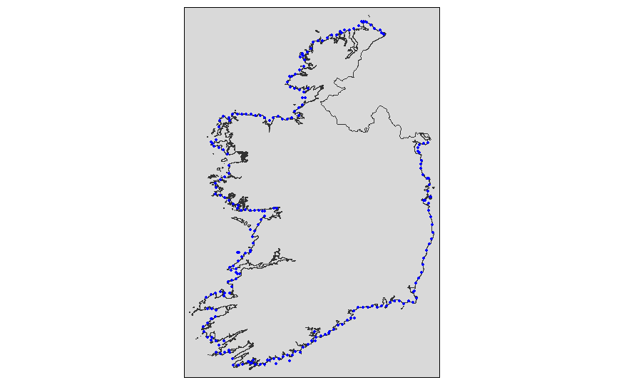

*Figure 1: All Stations where sea level surge data is Figure 2: Dun Laoghaire Station (795)  
available from the GTSR dataset*

To localise the preliminary exploratory analysis, Dun Laoghaire Station (station ID 795) serves as a representative example.

Summary statistics were calculated for the variable of interest, surge_daily_max in Dun Laoghaire:

*Table A: Summary Statistics (Meters) for surge_daily_max for station Dun Laoghaire.*

|  |  |  |  |  |  |
| --- | --- | --- | --- | --- | --- |
| Min. | 1st Qu. | Median | Mean | 3rd Qu. | Max. |
| -0.60200 | -0.03500 | 0.06000 | 0.09162 | 0.18400 | 2.85200 |

Table A presents the minimum, first quartile, median, mean, third quartile, and maximum values of the sea level surge daily maximum measurements.

The mean surge value (0.09162 meters) is slightly higher than the median (0.060 meters), suggesting a right-skewed distribution where higher surges might be more frequent or extreme. These values lie close to zero because we expect surge values to be zero except for in the case of extreme events. In addition, the maximum value is a lot higher than the 3rd Quartile, which highlights a presence of high outliers and extreme events. This is the area we will delve deeper into.

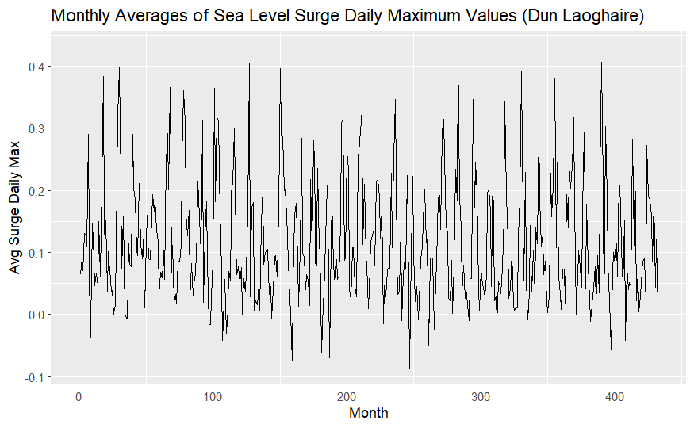

*Figure 3: Monthly Averages of Sea Level Surge Daily Maximum Values for Dun Laoghaire. The x-axis represents the months, while the y-axis shows the average surge values.*

*Figure 3* illustrates the monthly averages of sea level surge daily maximum values for Dun Laoghaire. This plot helps in identifying seasonal patterns and trends over time. The cyclical nature of the data shows the expected recurring seasonal variations, highlighting periods of higher and lower surge activity throughout the year.

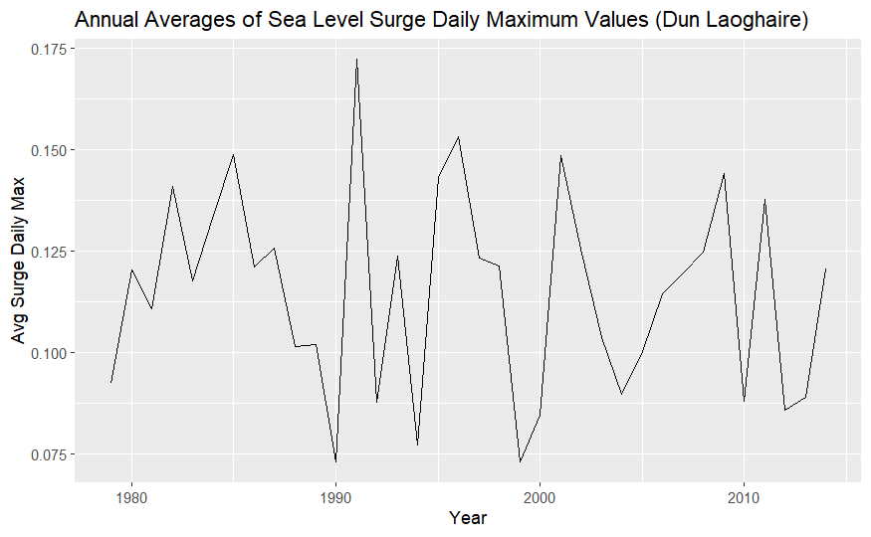

*Figure 4: Annual Averages of Sea Level Surge Daily Maximum Values for Dun Laoghaire Station. The x-axis represents the years, and the y-axis shows the average annual surge values.*

*Figure 4* presents the annual averages of sea level surge daily maximum values for Dun Laoghaire Station over the timeframe of the dataset. This plot highlights long-term trends and potential changes in sea level surges over the years. The variability in the plot indicates fluctuating surge levels, with certain years experiencing higher averages than others, suggesting periods of increased surge activity.

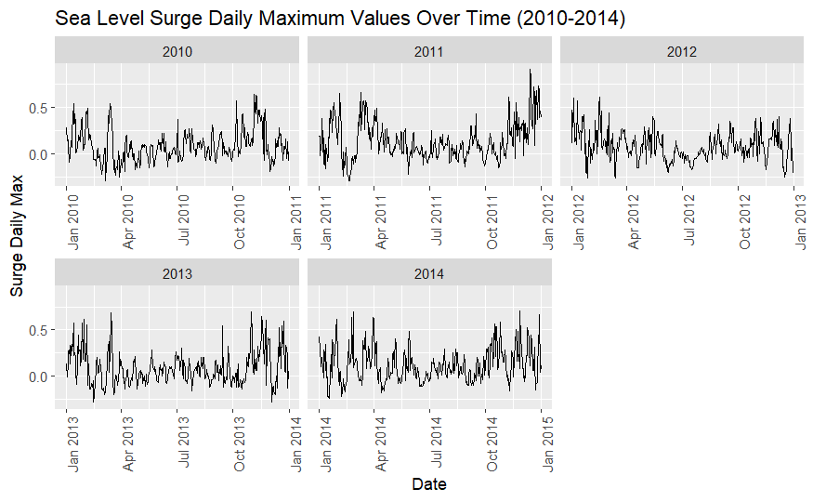



*Figure 5: Overview of the sea level surge daily maxima for Dun Laoghaire station from 2010-2014, a subset for clarity purposes. Highlighted in red are the chosen block maxima results.*

The analysis will consist of two different approaches of using a GEV distribution. Firstly, a block maxima approach considers the maximum value for given station each year as the extreme value (as shown in *Figure 5*). Each maximum point is used to populate the “extreme” value subset from which we fit the GEV distribution. The visualisation of the block maxima is as shown above.

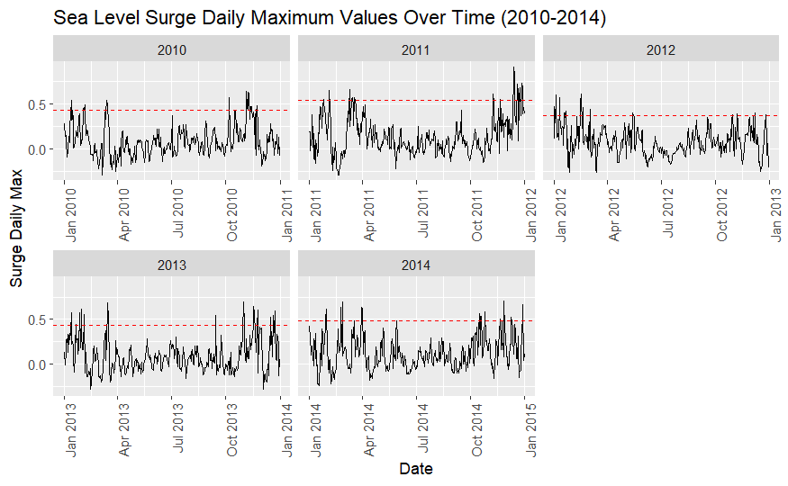

*Figure 6:* *Overview of the sea level surge daily maxima for Dun Laoghaire station from 2010-2014, a subset for clarity purposes. Values above the dashed line are the chosen threshold results.*

By comparison, a threshold analysis, or Peaks Over Threshold (POT) method, takes a given quantile of the data to use as the extreme subset. For this analysis, the 95th percentile is used as a threshold. Any points in the top 5% of values in each year will be considered to calculate the return levels for a given station. This method is highlighted above in *Figure 6*. According to the Fisher-Tippett-Gnedenko theorem, the block maxima converge to one of the Generalized Extreme Value (GEV) distributions: Gumbel, Fréchet, or Weibull. However, for a POT method, the Generalised Pareto Distribution, and specifically the Pareto distribution, are more adept at capturing the tail behaviour of the distribution. The convergence to the GPD, and thereby the Pareto distribution, when modelling exceedances over a high threshold is mathematically justified by the Pickands-Balkema-de Haan theorem (Pickands, 1975).

Both the block maxima and threshold approaches are to be tested, and their resulting return levels will be compared.

### **Model Implementation**

*Data Preparation:*

The analysis utilises data on storm surge return levels from various stations across Ireland. The specific variable used to quantify surges is *surge_daily_max* and it is varied by time (*date_time*) and by location through the variables *lon* and *lat*. Two methods for estimating return levels are employed: the Block Maxima (BM) method and the Peak Over Threshold (POT) method. The data for both methods are processed to include return levels for different periods (2-year, 5-year, 20-year, and 100-year) along with spatial coordinates of the stations.

*Load Libraries and Data:*

Various libraries are used throughout the project. Packages *dplyr* and *tidyr* are used for data manipulation. The extreme value analysis is performed using the *extRemes 2.0* package. Visualisations are created through the packages *cluster*, *sf*, *tmap*, and *ggplot2*. The dataset is first filtered to focus on the Dun Laoghaire station (795) for illustration purposes.

*Calculate Extremes and Fit Distributions:*

For both methods, the extreme values are calculated. In the BM approach, annual maximum values are calculated for each station, and a Generalised Extreme Values (GEV) distribution is fit. In the POT approach, for each station, a threshold is calculated based on the 99th percentile of daily maximum surge levels. The Generalised Pareto Distribution (GPD) is then fitted to the exceedances above this threshold.

*Estimate Return Levels:*

Return levels for specified return periods are estimated using the fitted GEV/GPD distributions.

*Visualisation:*

Return levels and the fitted GEV/GPD distributions are then visualised using plots. Additionally, maps depicting return levels across Ireland are created.

*Comparison and Visualisation:*

The differences between BM and POT return levels are visualised on a map, highlighting spatial variations in return levels across different methods.

# **3. Methods**

The first main objective of this paper is to model the extreme values of sea level surges using the Generalized Extreme Value (GEV) distribution. The GEV distribution is suitable for modelling the maximum or minimum of a dataset and is defined by the following parameters: location (𝜇), scale (𝜎), and shape (𝜉). In this case, we model the maxima. The GEV distribution encompasses three types of extreme distributions: the Gumbel, Fréchet and Weibull distributions. Each is used under different circumstances for modelling extreme values. The GEV can decide which of these distributions is most suitable and apply it. The notation for the model is:

ymax (s, t) | μ(s), σ(s), ξ(s) ∼ GEV (μ(s), σ(s), ξ(s))

In this equation, 𝑦max (𝑠, 𝑡) represents the maximum surge at location 𝑠 and time 𝑡, and 𝜇(𝑠) is the location parameter that varies over space. Location (𝜇) shifts the distribution along the x-axis, determining the central tendency of the maxima. (*s*) cause variation in (𝜇) allowing it to capture spatial factors. Scale, 𝜎(s), controls the spread or dispersion of the distribution, and shape, 𝜉(s), defines the tail behaviour, usually taking the form of Gumbel, Fréchet or Weibull distribution.

In practical terms, applying this distribution to our sea level surge data involves estimating parameters 𝜇(𝑠), 𝜎(s), and 𝜉(s). We can consider the spatial variability by allowing the parameter to vary over space. This allows us to calculate return levels for each location. It is important to note that this is modelling the spatial locations independently, i.e. this is not a spatial model but lots of independent models for each location. Further work on this topic could be considering a spatial model.

# **4. Results**

### **Block Maxima Model Fitting**

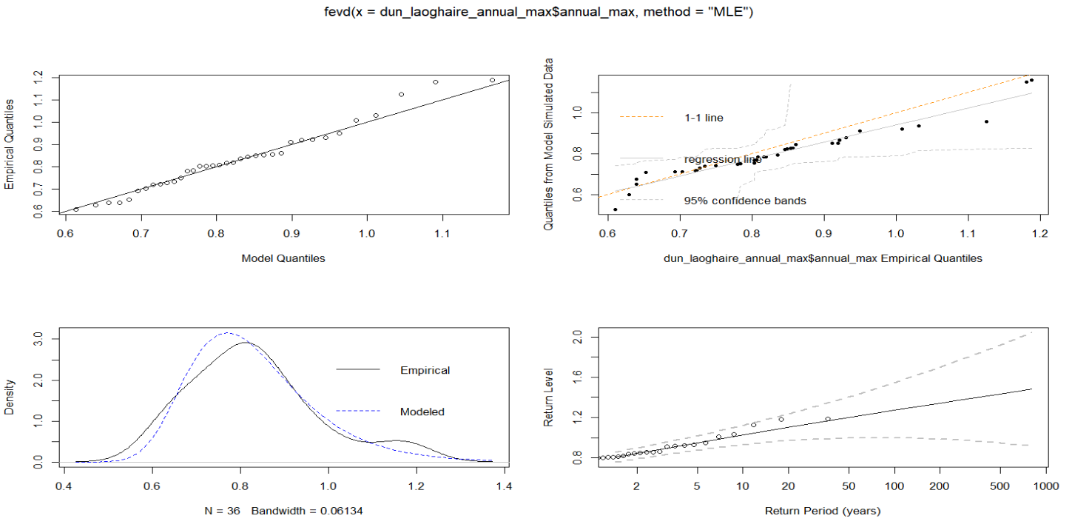

*Figure 7: Forecast Error Variance Decomposition (FEVD) for extreme value indices. The four-panel plot illustrates how the contribution of each index to the forecast error variance changes across different time horizons. Each panel represents the decomposition for one extreme value index, showing its relative impact on the forecast error variance over time.*

We are fitting the data using the ‘fevd’ function from the ‘extRemes’ package in R. *Figure 7* shows four panels relating fitting the data to a GEV distribution using the block maxima approach. To reiterate, the following results are for our case study location of Dun Laoghaire, however similar results can be seen across all locations.

The top left plot shows the resulting Q-Q plot after fitting the model. Comparing the quantiles of the observed data versus the quantiles of the GEV model assume a good fit, with most points lying close to the 45-degree line.

The probability plot in the top right assesses the goodness of fit with the x-axis representing the empirical quantiles of the observed data and the y-axis demonstrating the quantiles from the model’s simulated data. Most points are on or very close to the 1-1-line, indicative of a near-perfect fit.

The density plot compares the density of the observed data with the density implied by the model. The empirical and modelled lines show significant overlap which implies good fit.

Finally, the return level plot (bottom right) shows estimated return levels for different return periods based on the GEV fitted model. The x-axis shows the logarithmic return period (years) and the y-axis shows the return level for which storm surge height is expected to be exceeded once every given period of return. Return level estimates are all inside the 95% confidence interval (the dashed lines) which again shows a strong reliability for estimating extreme sea level surges.

### **Block Maxima Results**

Firstly, the GEV is fitted to the data associated with station 795. This provides a singular point of comparison in assessing the strength of fit of the model. The Generalized Extreme Value (GEV) distribution parameters using the block maxima approach were estimated using the Maximum Likelihood Estimation (MLE) method. The negative log-likelihood value for the model fit was -20.97111, indicating reasonable fit to the annual maximum surge data.

The estimated parameters for the GEV distribution are as follows: location (μ) = 0.7659, scale (σ) = 0.1167, and shape (ξ) = -0.0274. The standard errors for these estimates are 0.0222, 0.0162, and 0.1354 respectively, suggesting acceptable precision in the parameter estimates.

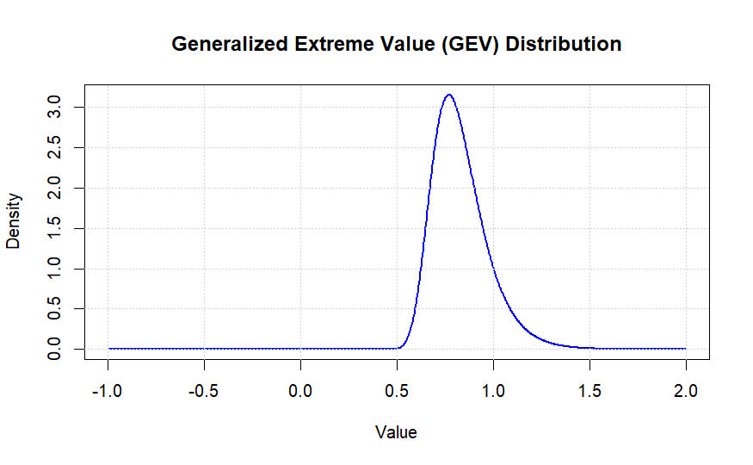

*Figure 8: Block maxima extreme value distribution for station 795 (Dun Loaghaire).*

*Figure 8* shows the resulting distribution of the extreme values for station 795 (Dun Laoghaire). The shape parameter being very close to zero suggests a Gumbel distribution.

The covariance matrix of the parameter estimates is shown in Table X (Appendix). This matrix provides insights into the relationships between the estimated parameters, with off-diagonal elements indicating the covariances.

The Akaike Information Criterion (AIC) and Bayesian Information Criterion (BIC) values for the model are -35.94222 and -31.19166, respectively. These values support the adequacy of the model for the given data. We will compare these results with those form the Peaks-Over-Threshold method in the next section.

For station 795, the return levels for 2-year, 5-year, 20-year, and 100-year periods were estimated as 0.8085, 0.9374, 1.0989, and 1.2704 meters, respectively. The 95% confidence intervals for these return levels provide a range within which the true values are expected to lie, indicating the uncertainty in these predictions (Table Y - Appendix).

The GEV model was applied to all the stations in the dataset. The resulting return levels for the 2, 5, 20 and 100-year return levels were then plotted on a heatmap of the Irish coast as shown in *Figure 9* below.

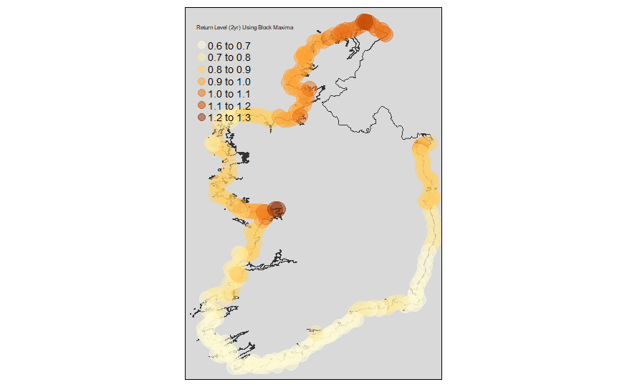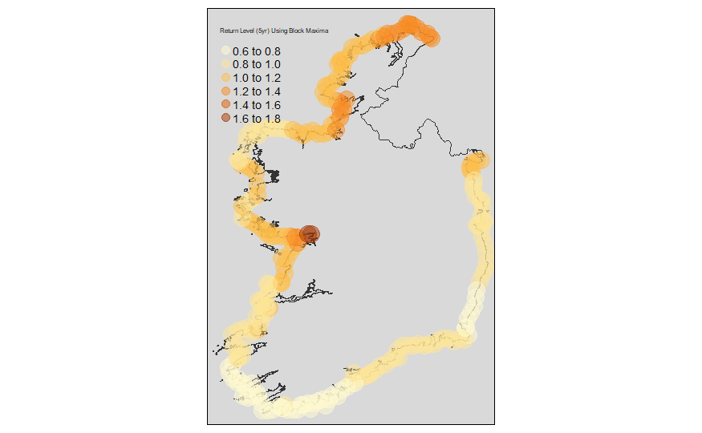

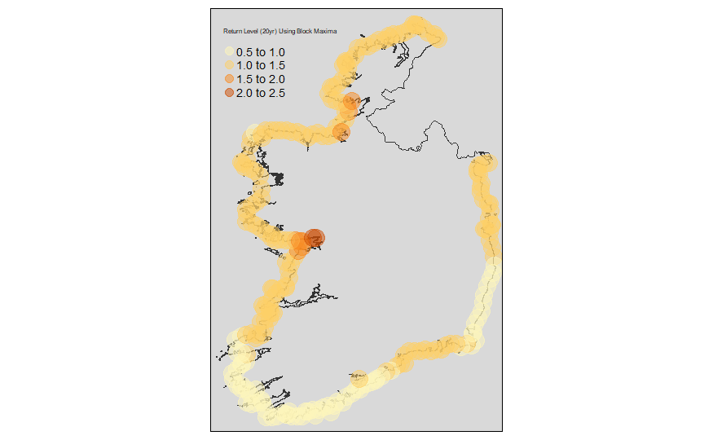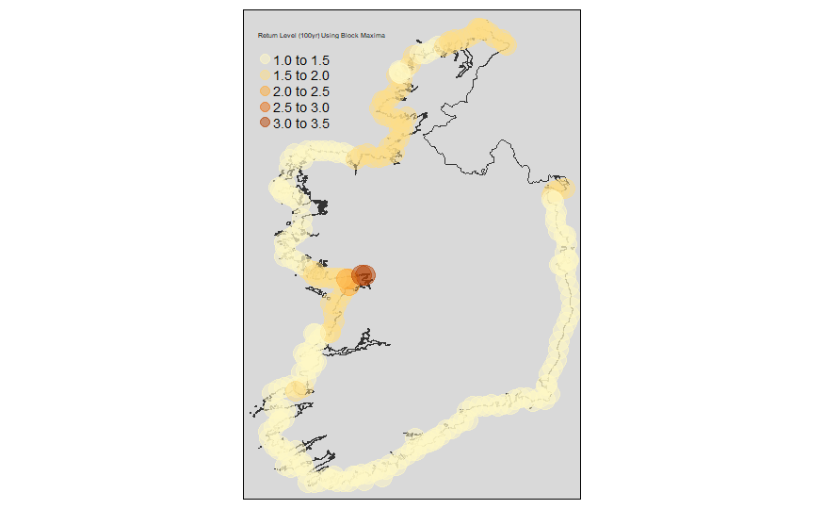

*Figure 9: Block maxima calculated return levels mapped continuously for the 2-, 5-, 20-, and 100-year periods respectively.*

*Figure 9* shows the block maxima calculated return levels around the coast for 2-, 5-, 20-, and 100-year periods respectively. Darker coloured areas indicate higher return levels while lighter colours have lower return levels.

The next objective was to calculate the exceedances of the 5-year return level for each station. Again, station 795 is used initially to plot a singular location’s exceedance count over time.

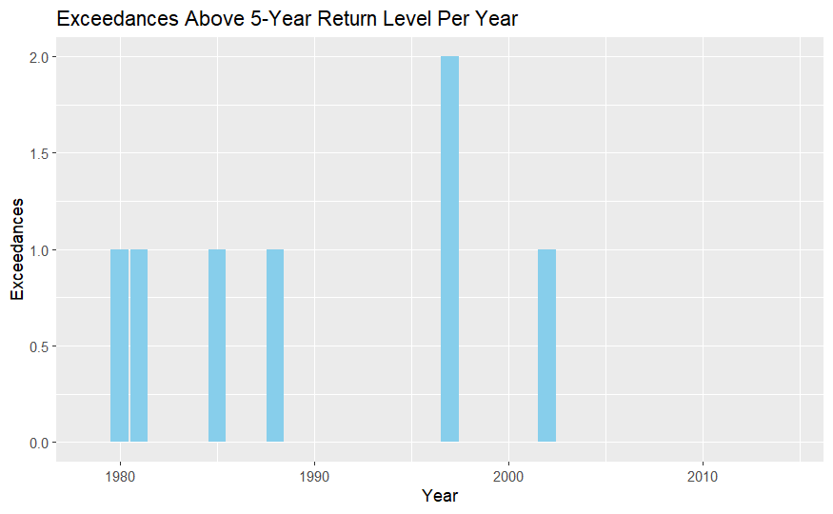

*Figure 10: Dun Laoghaire exceedance counts of 5-yr return level (Block Maxima).*

*Figure 10* shows the exceedance counts where sea surge spiked above the 5-year return level in Dun Laoghaire station 795, for each year.

Before looping this process to count exceedances of the 5-year level, it is important to cluster our locations to more easily draw conclusions and meaning from the final exceedance analysis. Location clustering was performed to group stations into different coastal groups: North, East, South, and West.

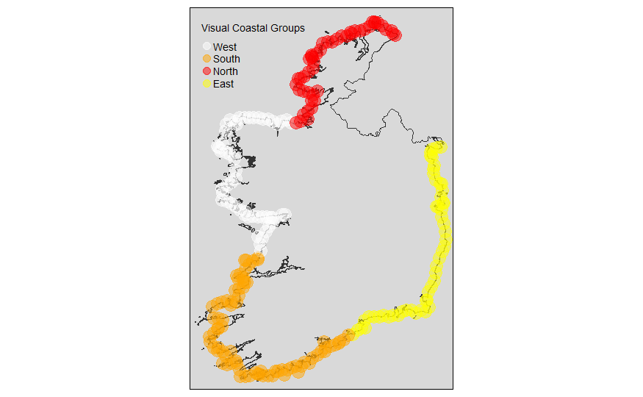

*Figure 11: Coastal grouping resulting from a k=4 location clustering using k-means.*

*Figure 11* shows the results of the K-means clustering. Four major coastal regions are identified through a clustering on location geometries and labelled according to their approximate facings: North, West, South and East.

Note that this visual is based on the location variable alone and does not include any sea surge data. The clustering of coastal regions serves solely to provide greater context and an approximate grouping for the temporal clustering of exceedances.

The next step is to map the exceedances of the 5-year and 2-year return levels across all stations and group/cluster them based on the North, South, East, West grouping. This will give us a visual of areas within close proximity which experience exceedances above the 5/2-year level in a given year.

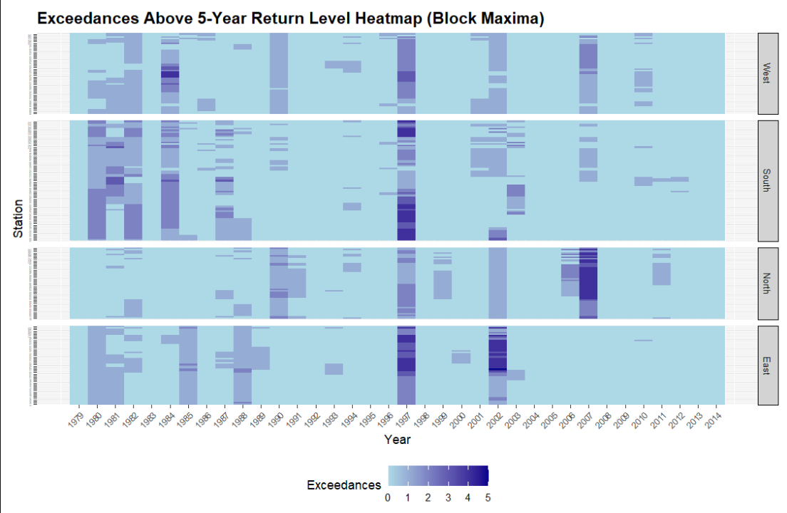

*Figure 12: Temporal clustering heatmap of exceedances of the 5-year return level by each station over time, grouped by coast.*

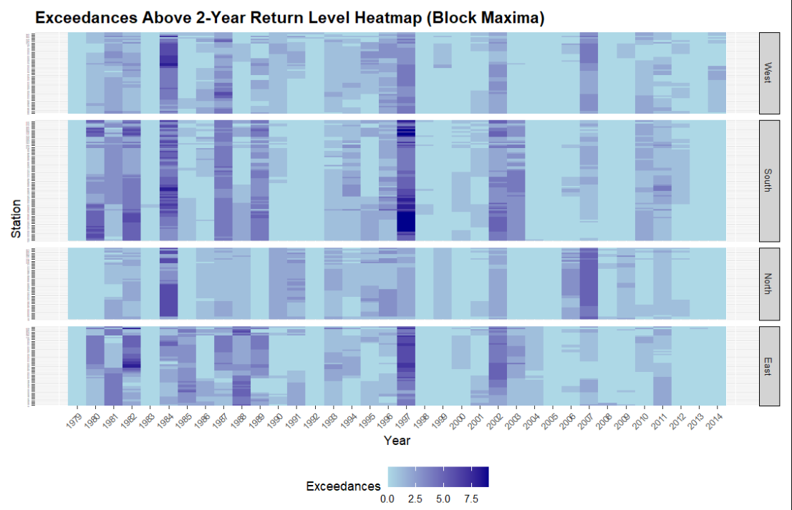

*Figure 13: Temporal clustering heatmap of exceedances of the 2-year return level by each station over time, grouped by coast.*

*Figures 12* and *13* shows a temporal clustering analysis heatmap of exceedances above the 5-year and 2 -year return levels. Grouped by coastal regions, the y-axis represents the coastal stations. The x-axis shows the years of the dataset from 1979-2014. Darker areas of the heatmap indicate higher exceedances in the given year for that given station.

*Table B: Average exceedances by cluster group of 5-year return level using a Block Maxima method.*

|  |  |  |  |
| --- | --- | --- | --- |
| Cluster | Exceedance Count (5yr) | Station Count (5yr) | Exceedances per Station (5yr) |
| West | 509 | 53 | 9.60 |
| South | 886 | 79 | 11.22 |
| North | 490 | 47 | 10.43 |
| East | 549 | 52 | 10.56 |

*Table C: Average exceedances by cluster groups of 2-year return level using a Block Maxima method.*

|  |  |  |  |
| --- | --- | --- | --- |
| Cluster | Exceedance Count  (2yr) | Station Count (2yr) | Exceedances per Station (2yr) |
| West | 1801 | 53 | 33.98 |
| South | 3712 | 79 | 46.98 |
| North | 1641 | 47 | 34.91 |
| East | 2210 | 52 | 42.50 |

Tables B and C show the cluster groups, their respective exceedance counts, station counts, and the exceedances per station, for the 5-year and 2-year return levels. By 5-year returns, the South cluster is the highest in exceedances per station with 11.22, and a difference of 0.66 exceedances to the East cluster in second. Closely following is the North, then the West cluster yielding the least exceedances per station. At a 2-year return level, the South has a larger lead in exceedances with 46.98 exceedances, followed by East, North, and West. The results of the block maxima indicate a tendency for the South to be more vulnerable to spikes above 2-year and 5-year levels relative to the rest of the coastline.

### **Peaks-Over-Threshold (POT) Model Fitting**

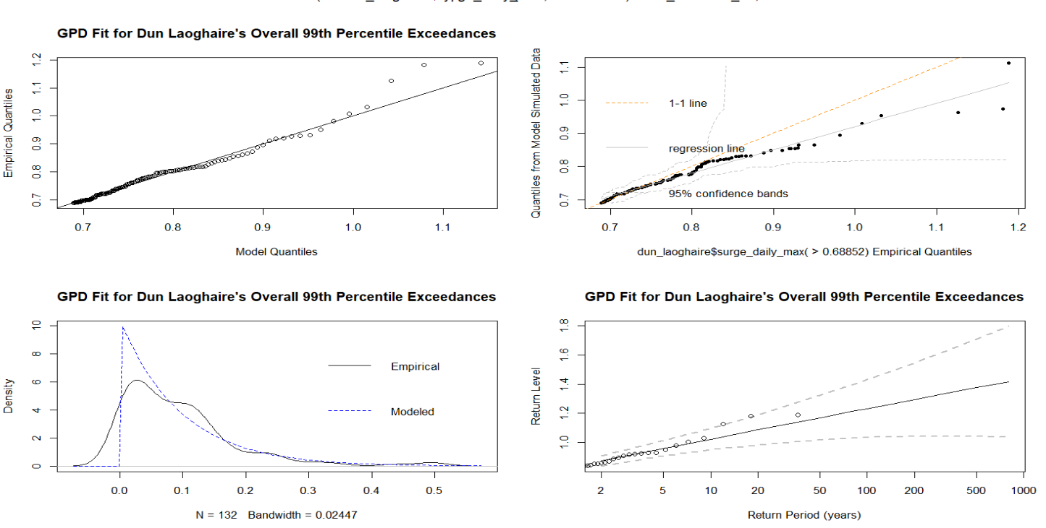

*Figure 14: Forecast Error Variance Decomposition (FEVD) for extreme value indices. The four-panel plot illustrates how the contribution of each index to the forecast error variance changes across different time horizons. Each panel represents the decomposition for one extreme value index, showing its relative impact on the forecast error variance over time.*

We are fitting the data using the ‘fevd’ function from the ‘extRemes’ package in R. *Figure 14* shows four panels relating fitting the data to a GPD distribution using the POT approach. A threshold of the 99th percentile is chosen, as to capture only the most extreme events as data points for modelling. To reiterate, the following results are for our case study location of Dun Laoghaire, however similar results can be seen across all locations.

The top left plot shows the resulting Q-Q plot after fitting the model. Comparing the quantiles of the observed data versus the quantiles of the GPD model assume a good fit, with most points lying close to the 45-degree line. There may also be a couple of outliers seen in the higher quantiles.

The probability plot in the top right assesses the goodness of fit with the x-axis representing the empirical quantiles of the observed data and the y-axis demonstrating the quantiles from the model’s simulated data. Most points, except a small number of potential outliers, are on or very close to the 1-1-line, indicative of a good fit.

The density plot compares the density of the observed data with the density implied by the model. The empirical and modelled lines do not show a strong correlation in the bulk of the data. The GPD is specifically designed to model the tail behaviour of the distribution beyond the 99th percentile threshold. As such, it can result in a steep curve, especially when focusing on extreme values, which are inherently sparse and variable. This steepness in the modelled curve is a reflection of the heavy-tailed nature of extreme value distributions. The inherent nature of the threshold method is shown in this density plot, but it is not a reason to disregard it due to reasons of lack of fit. The Q-Q plot and return level plots can validate the goodness of fit for the tail end of data.

Finally, the return level plot (bottom right) shows estimated return levels for different return periods based on the GPD fitted model. The x-axis shows the logarithmic return period (years) and the y-axis shows the return level for which storm surge height is expected to be exceeded once every given period of return. Return level estimates are all inside the 95% confidence interval (the dashed lines) which again shows a strong reliability for estimating extreme sea level surges.

### **Peaks-Over-Threshold Results**

The same methods will be applied to the data in this section using a Peaks-Over-Threshold (POT) approach instead of a block maxima approach. Again, we use station 795 Dun Laoghaire as a comparison location. The key difference in for the POT is that we are fitting a Generalised Pareto Distribution (GPD) to the values above the threshold. The GPD distribution parameters are scale and shape. We do not estimate the location parameter in this case because the location is the threshold itself, which is chosen to be the 99th percentile. The scale and shape parameters are estimated using the Maximum Likelihood Estimation (MLE) method. The negative log-likelihood value for the POT model fit was -180.0479, indicating a significantly lower and therefore better fit to the annual maximum surge data.

The estimated parameters for the GEV distribution are as follows: scale (σ) = 0.095 and shape (ξ) = -0.0104. The standard errors for these estimates are 0.0116 and 0.0857 respectively, suggesting acceptable precision in the parameter estimates.

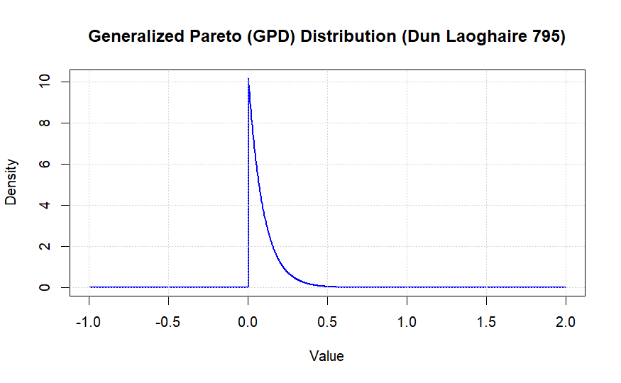

*Figure 15: Generalised Pareto Distribution (POT Method) for station 795 (Dun Loaghaire).*

*Figure 15* shows the resulting distribution of the extreme values for station 795 (Dun Laoghaire). The covariance matrix of the parameter estimates is shown in Table V (Appendix) with one less parameter than before, excluding location.

The Akaike Information Criterion (AIC) and Bayesian Information Criterion (BIC) values for the model are -356.1 and -350.3, respectively. These values are ten-fold lower than the comparable results in the block maxima approach, supporting strongly the suitability of the model for the given data.

For station 795, the return levels for 2-year, 5-year, 20-year, and 100-year periods were estimated as 0.8759, 0.9608, 1.0877 and 1.2327 meters, respectively. The 95% confidence intervals for these return levels provide a range within which the true values are expected to lie, indicating the uncertainty in these predictions (Table W - Appendix).

The GPD model was applied to all the stations in the dataset. The resulting return levels for the 2, 5, 20 and 100-year return levels were then plotted on a heatmap of the Irish coast as shown in figure 17 below.

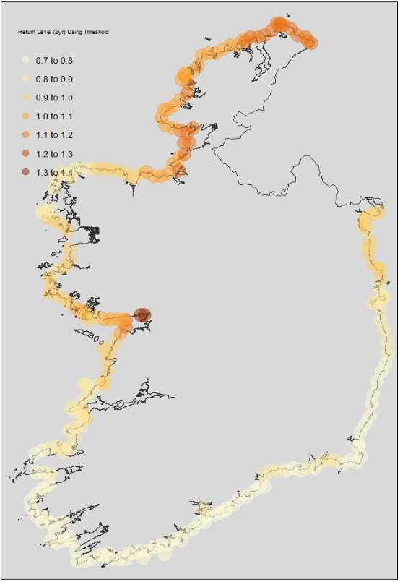 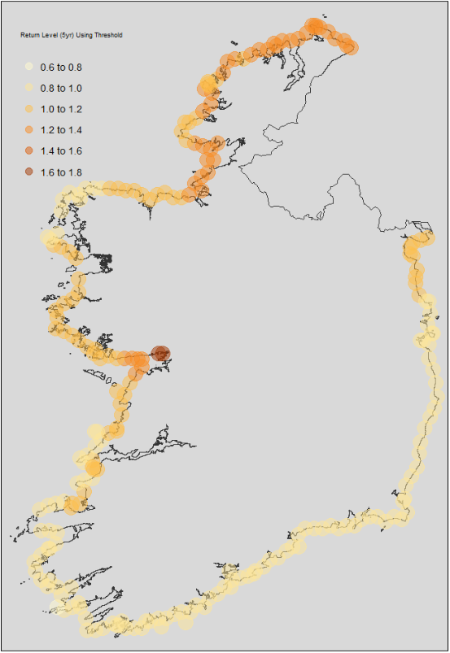

*Figure 16: Peaks-Over-Threshold calculated return levels mapped continuously for the 2-, 5-, 20-, and 100-year periods respectively.*

*Figure 16* shows the POT calculated return levels around the coast for 2-, 5-, 20-, and 100-year periods respectively. Darker coloured areas indicate higher return levels while lighter colours have lower return levels.

We follow the same order of objectives by calculating the exceedances of the 5-year return level for each station. Again, station 795 is used initially to plot a singular location’s exceedance count over time.

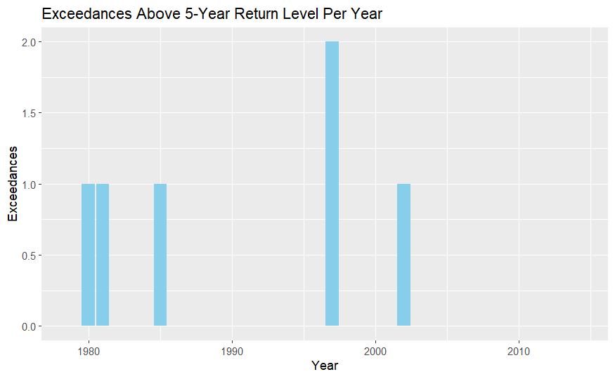

*Figure 17: Dun Laoghaire exceedance counts of 5-yr return level (Peaks-Over-Threshold).*

*Figure 17* shows the exceedance counts where sea surge spiked above the 5-year return level in Dun Laoghaire station 795, for each year. This yields similar results to the exceedances for station 795 using block maxima.

The next step is to map the exceedances of the 5-year and 2-year return levels across all stations and group/cluster them based on the North, South, East, West grouping. This will give us a visual of areas within close proximity which experience exceedances above the 5/2-year level in a given year.

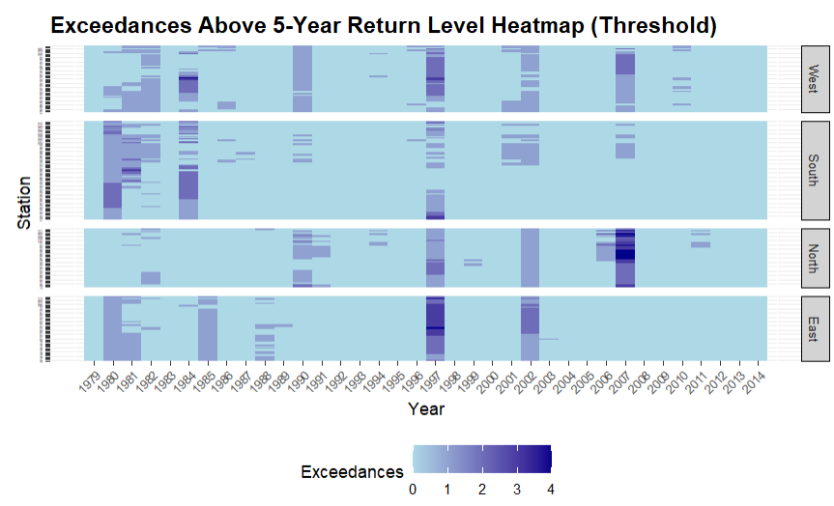

*Figure 18: Temporal clustering heatmap of exceedances of the 5-year return level by each station over time, grouped by coast (POT Method).*

*Figure 19: Temporal clustering heatmap of exceedances of the 2-year return level by each station over time, grouped by coast (POT Method).*

*Figures 18* and *19* show a temporal clustering analysis heatmap of exceedances above the 5-year and 2 -year return levels. Grouped by coastal regions, the y-axis represents the coastal stations. The x-axis shows the years of the dataset from 1979-2014. Darker areas of the heatmap indicate higher exceedances in the given year for that given station.

We can then compare the results of the block maxima exceedance analysis with the same results using a Peak-Over-Threshold method.

*Table D: Average exceedances by cluster group of 5-year return level using a Peaks-Over-Threshold (POT) Method.*

|  |  |  |  |
| --- | --- | --- | --- |
| Cluster | Exceedance Count  (5yr) | Station Count (5yr) | Exceedances per Station (5yr) |
| West | 415 | 53 | 7.83 |
| South | 413 | 79 | 5.23 |
| North | 342 | 47 | 7.28 |
| East | 363 | 52 | 6.98 |

*Table E: Average exceedances by cluster group of 2-year return level using a Peaks-Over-Threshold (POT) Method.*

|  |  |  |  |
| --- | --- | --- | --- |
| Cluster | Exceedance Count  (2yr) | Station Count (2yr) | Exceedances per Station (2yr) |
| West | 961 | 53 | 18.13 |
| South | 1377 | 79 | 17.43 |
| North | 1061 | 47 | 22.57 |
| East | 873 | 52 | 16.79 |

In the POT approach, we find a difference in the ranking of clusters. The West cluster leads exceedances for the 5-year return levels, while the South cluster this time experiences the lowest exceedances. At a 2-year return, the North cluster has the most exceedances and the East experiences the least. A notable feature of the exceedance results using a POT approach is that there are much less exceedances of both the 5 and 2-year levels.

Finally, it is important to understand how the return levels differ between the Block Maxima and POT approaches. We can map these differences for visual purposes.

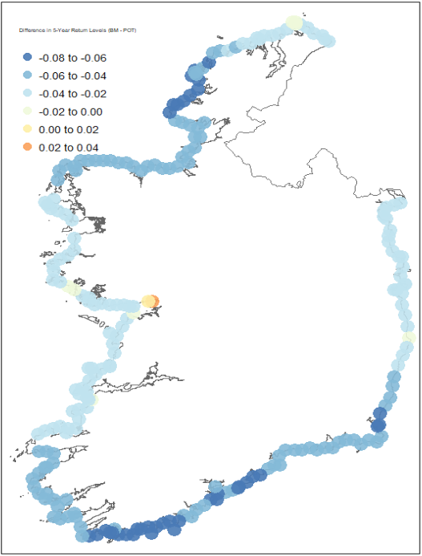

*Figure 20: Map showing which locations yield higher 5-year return levels for the POT method vs the BM method.*

*Figure 20* shows the actual differences in the calculated 5-year return levels for the Block Maxima method versus the POT method. The differences are shown on a blue/yellow/red continuous colour scale, with negative differences (blue) showing areas with higher estimations in the POT analysis and positive differences (red) showing areas with higher estimations on the Block Maxima.

# **5. Discussion**

The block maxima extreme analysis produced a valuable temporal clustering heatmap which shows a time and location for specific clustering events of sea surge exceedances above a 5-year return level. In theory, given the close relationship between sea surge and storm surge, this heatmap should reasonably coincide with actual storm events, and show the areas which are vulnerable during those events.

As a validation measure, Ireland’s national meteorological service, Met Eireann’s reporting of major weather events should correlate tightly with the temporal clustering heatmap. Large clustering exceedances appear in 2007 (North), 2002 (East/South), 1997 (East/South), and 1984 (West/North). Met Eireann reports 2 flooding events on the east and south coasts in 2002, as well as extensive flooding in the south and east and a windstorm event in 1997. These two years match our analysis perfectly. However, the large clusters in 2007 and 1984 do not seem to have correlating major event reports by Met Eireann, suggesting a missing link in our analysis.

There are some reasons which may help to explain this discrepancy between the data and the storm reports. Firstly, perhaps sea surge data on its own is not fully predictive of storm events. There may be other influences on sea surges which are not related to storm surges. Astronomical tides can cause extreme sea surges, better known as spring tides or king tides. These occur when the gravitational alignment of the moon, sun and Earth align, causing higher than normal tides (Woo, 2014).

Seiches are standing waves which oscillate in enclosed or partially enclosed bodies of water, such as bays or lakes. Seiches are caused by sudden changes in atmospheric pressure, strong winds or seismic activity (Encyclopedia Britannica). Seiches may affect areas such as Galway Bay or Dublin Bay and may explain why return levels are calculated much higher in Galway Bay, leading it to be grouping outlier in the k-means clustering analysis.

Oceanic and atmospheric patterns, such as the North Atlantic Oscillation (NAO), may be a factor influencing sea surges around the Irish coast. "The North Atlantic Oscillation influences the climate variability in the region and can lead to significant sea level changes along the Irish coast" (Dahlman, 2009).

Another possibility is that the hydrodynamic model, the GTSM, is not fully accurate in simulating sea surges around the Irish coastline. The GTSM is widely used for predicting tidal and storm surges. However, like any model, it has limitations. Ireland has a varied and complex coastline. Resolution limitations, or the inability to accurately capture nuances such as coastal topography and bathymetry, small bays, estuaries and coastal shelves, which are prevalent around Ireland, may be causing inaccuracies in the data simulation. This point is made multiple times by Wang et. Al., 2021: “Although the behavior of tides and surges is quite linear for the deep ocean and steep coasts, there may be significant non-linear interaction between tides and surges on the coastal shelf." They also mention that the GTSM uses an unstructured grid to “apply a higher resolution near the coast where the spatial scales are smaller." This acknowledges that coastal areas require higher spatial resolution due to their smaller scales, and implies that without this higher resolution, the model might not capture accurately the coastal dynamics.

Model calibration and validation may play a part too. If the GTSM is not calibrated with local data specific to the Irish coastline it may produce inaccurate results. Stammer et. Al, 2014 outlines the importance in continuous calibration with local observational data, after a review of the accuracy of different global tide models.

Finally, perhaps Met Eireann’s reports are not inclusive of smaller storm events, or more localised events, which may account for the exceedances in the heatmap. A possible issue is that the threshold for what is considered a “reportable” major weather event is too high to capture the 2007 and 1984 exceedance clusters. There may have been storms regardless which disproportionately yielded higher sea surges than a typical storm of the same size. Otherwise, the reports may be national in scope and not register more localised events which cause sea surges.

Regardless of the potential limitations and unknown reasons behind some exceedance clusters, the clustering of exceedances clearly identifies known major weather events accurately. Using the results, we can simply sum the total exceedances for each coastal grouping and divide by the number of stations within each given group to measure the “vulnerability” of each coastal group. This vulnerability is assuming that more spikes above the 2 and 5-year return levels are causing more frequent sea surges above the expected or normal observed levels, which in turn indicates more extreme events compared to other locations. We exclude larger return levels (20 and 100 year) because they do not provide enough exceedances to draw meaningful conclusions from given our 35-year history in this dataset.

### **Higher Return Levels with the POT Method**

The POT analysis is calculating higher return levels which is resulting in less exceedances. Understanding why the POT method would return higher levels than the BM method is an important in drawing conclusions from the analysis. There are several reasons which may explain this variability.

The variability may be impacted by the ability of the POT method to capture a higher number of very extreme events which may cause high sea surges multiple times over the course of days. This more detailed view may be accounting for high-magnitude events which would only be counted once in the BM method, which takes only the maximum result.

There may also be statistic modelling differences. The POT method uses a Generalised Pareto Distribution which fits the tail of the data more precisely by using multiple exceedances. This GPD tail is more sensitive to rare, high extremes which can result in higher estimated return levels, especially for longer return periods.

The threshold selection is crucial in the POT analysis. A lower threshold will include more moderate events, while higher thresholds will focus on more extreme values. The threshold used in this case is a 99th percentile, which could be including only the highest data points, causing the return levels to rise.

Ultimately, the variability in extreme values is likely to influence the higher return levels. Regions with high variability or more frequent severe events are captured better by the POT. This will cause the fitted distribution to predict higher return levels as it is more sensitive to extreme data, especially when choosing a high threshold.

### **Interpretation of Results**

Given that POT is yielding higher return levels than BM in this analysis, this might indicate several insights about the coastal clusters:

*POT Sensitivity to Frequent Extremes*

The POT leading to higher return levels suggests that there are frequent significant surges in the majority of locations around the coastline, and indicates that for locations where this is true, consistent moderate to extreme events are more likely. This sensitivity means that the POT captures the clustering of extreme events better, which is crucial in understanding the overall exposure and risk.

*Figure 20* in the results section illustrates a comparison of the 5-year return levels calculated using both methods. Blue areas show where the 5-year return level was higher for POT than BM, and the red shows vice versa. The blue areas are suggestively more prone to frequent significant sea level surges. The red areas, specifically Galway Bay, by comparison experience less common but more extreme events.

Ultimately, the POT is considering multiple significant surges within the same year which provides a broader view of extreme event frequency. The BM method is sensitive to the single largest event in a year, making it influenced by rare, exceptionally high surges. Blue zones (where 5-yr return levels for POT > BM) have typically more frequent extreme events, while Galway Bay which represents the red zone is prone to rare but extremely significant surges. The blue zones, by experiencing more consistent moderate to extreme surges, are more vulnerable to damage over time, impacting infrastructure, erosion rates and coastal ecosystems. Red zones are more vulnerable to severe extreme sea surges, which have potential for catastrophic events, and should be more prepared against emergency situations with resilient infrastructure in place.

# **6. Conclusion**

### **Summary of Objectives**

The primary goals of this analysis were to: (a) Characterise sea-level extremes by focusing on the extremes, or tail-ends of the distribution. (b) Estimate the return levels for different time intervals to quantify the magnitude of expected extreme sea level surges across the Irish coastline. (c) Assess the temporal clustering of exceedances using the 1-in-2 and 1-in-5-year return levels, identifying coastal areas with high exceedances of these levels. (d) Compare these results across two methods of extreme analysis: the BM and POT methods. (e) Evaluate the vulnerabilities of each location based on the results of the two extreme analysis methods.

### **Return Levels**

Return levels were generally seen to be higher for the POT method across most stations. However, some stations seen higher return levels for BM, particularly Galway Bay. Therefore, this analysis underscores the importance of using both BM and POT methods to get a comprehensive understanding of coastal vulnerabilities. Each method highlights different aspects of extreme event behavior, which together provide a fuller picture of risk and exposure along the Irish coastline. The method comparison map in *figure 20* visually represents these differences and guides coastal management and planning efforts in addressing both frequent moderate extremes and rare severe events.

### **BM Focus on Annual Extremes**

The BM highlights the most extreme event in each year which might result in a lower return level for frequent events. It may be smoothing out the impact of several extreme events in a year, providing a more conservative estimate for the lower return periods (5-yr and 2-yr). This may imply that regions with infrequent but very severe events appear less vulnerable in the BM analysis, even if they experience multiple significant extreme events per year.

### **Practical Implications**

For regions such as the South cluster, identified as the most vulnerable per the BM method, the focus should be on preparing for rare, severe surges. In contrast, the POT recognises regions which are vulnerable to more frequent and moderate extremes, and so the focus for the North cluster, which has the most exceedances at a 2-yr return level, should be to prepare for moderate but frequent events. This dual approach helps in crafting a more nuanced strategy around coastal management which splits regions into areas which face different types of surges.

### **Limitations**

Some limitations were recognised during the validation of the return level exceedances back to reported Met Eireann storm events, where there were noticeable clusters of exceedances in some areas which have not been reported by Met Eireann. This leads to a discussion around why there are ‘extra’ surges in this analysis. Underreporting or lack of nuanced reporting, limitations with the GTSM model or its calibration, and non-atmospheric causes of sea surges could all play a role in this observed discrepancy.

### **Recommendations**

Future research on this topic should incorporate additional environmental factors which may interact with sea-surges and provide a clearer view of the real underlying storm surge causes. Using wind speed and direction data, or tidal data may be a good basis for identifying further vulnerabilities in the Irish coastline. Furthermore, a review of the GTSM and cross-validation with historical events may prove to further calibrate the model to fit for the region of Ireland.

Using different extreme analysis methods, such as Bayesian or joint probability methods may also be valuable to add detail to the reality of sea surge extremes. Analysing non-meteorological causes to sea-surges, such as seismic activity or underwater land shifts, would improve the understanding of these factors and provide a more holistic view of surge dynamics. Finally, the objective of this research is to assist in coastal defence and management strategies. Should this research be expanded upon in the future, the ways which vulnerabilities between different coastal areas differ should be taken into account for coastal defence strategies.

### **Final Thoughts**

This analysis of sea-level extremes using Block Maxima (BM) and Peaks Over Threshold (POT) methods provides valuable insights into the magnitude and frequency of extreme surge events along the Irish coastline. The use of these methodologies reveals different aspects of extreme event behaviour and is crucial for understanding coastal vulnerabilities.

The comparative results between BM and POT methods highlight that each approach offers unique perspectives on extreme surges. BM emphasises only the most severe annual events, providing a conservative estimate for less frequent, high-impact events. Conversely, POT focuses on the exceedances above high thresholds, capturing more frequent but potentially less severe surges. This dual approach underscores the importance of using both methods to achieve a comprehensive assessment of coastal risk.

The observed discrepancies in return levels between methods, especially in regions like Galway Bay, indicate that vulnerability assessments should account for both frequent moderate extremes and rare severe events. Coastal management strategies must therefore be nuanced, addressing areas with varying levels of risk based on their susceptibility to different types of extreme events.

Despite the robustness of the analysis, several limitations and discrepancies, such as the presence of unreported surges, suggest areas for improvement. Future research should consider additional factors which could be influencing sea-level extremes, enhance model calibration, and incorporate broader data sources to refine an understanding and the predictive capabilities for future extreme events.

Ultimately, this study emphasises the need for a multifaceted approach to coastal management and planning. By integrating insights from both BM and POT methods, and addressing the recommendations provided, stakeholders can better prepare for and mitigate the impacts of extreme sea-level events. This holistic understanding is essential for developing effective strategies to protect coastal communities and infrastructure in an increasingly variable climate.

# **7. References**

Central Statistics Office (CSO) (2019) 'Press statement census 2016 results profile 2 - population distribution and movements'. Available at: https://www.cso.ie/en/csolatestnews/pressreleases/2017pressreleases/pressstatementcensus2016resultsprofile2-populationdistributionandmovements/ (Accessed 19 June 2024).

Dacre, H.F. and Pinto, J.G. (2020) 'Serial clustering of extratropical cyclones: a review of where, when and why it occurs', NPJ Climate and Atmospheric Science, 3, p.1-10. Available at: https://doi.org/10.1038/s41612-020-00152-9 (Accessed 4 June 2024).

Dahlman, R.L.A.L. (2009) 'Climate variability: North Atlantic Oscillation', NOAA Climate.gov. Available at: https://www.climate.gov/news-features/understanding-climate/climate-variability-north-atlantic-oscillation (Accessed 13 May 2024).

Department of Housing, Local Government and Heritage (2023) 'Report of the Inter-Departmental Group on National Coastal Change Management Strategy'. Available at: https://www.gov.ie/en/publication/a43f3-report-of-the-inter-departmental-group-on-national-coastal-change-management-strategy/ (Accessed 19 June 2024).

Encyclopædia Britannica (n.d.) 'Seiche'. Available at: https://www.britannica.com/science/seiche (Accessed 20 June 2024).

Environmental Protection Agency (EPA) (2021) 'EPA Climate Ireland | Coastal Flooding'. Available at: https://www.climateireland.ie/impact-on-ireland/climate-hazards/coastal-flooding/ (Accessed 13 May 2024).

Environmental Protection Agency (EPA) (2021) 'Inland flooding'. Available at: https://www.epa.ie/our-services/monitoring--assessment/climate-change/climate-ireland/impact-of-climate-change-on-ireland/climate-hazards/inland-flooding/ (Accessed 19 June 2024).

Government of Ireland (2020) Irish Coastal Protection Strategy Study (ICPSS). Available at: https://www.gov.ie/en/publication/eed0fb-irish-coastal-protection-strategy-study-icpss/ (Accessed 24 May 2024).

Griggs, G. and Reguero, B.G. (2021) 'Coastal Adaptation to Climate Change and Sea-Level Rise', Water, 13(16), p.2151. Available at: https://doi.org/10.3390/w13162151 (Accessed 24 May 2024).

Hallegatte, S., Green, C., Nicholls, R. and Corfee-Morlot, J., 2013. Future flood losses in major coastal cities. *Nature Climate Change*, 3, pp.802-806. Available at: https://doi.org/10.1038/nclimate1979 (Accessed 1 August 2024).

Hauer, M., Fussell, E., Mueller, V., Burkett, M., Call, M., Abel, K., McLeman, R. and Wrathall, D., 2019. Sea-level rise and human migration. *Nature Reviews Earth & Environment*, 1, pp.1-12. Available at: https://doi.org/10.1038/s43017-019-0002-9 (Accessed 1 August 2024).

IPCC, 2021. Climate Change 2021: The Physical Science Basis. Contribution of Working Group I to the Sixth Assessment Report of the Intergovernmental Panel on Climate Change. Available at: https://www.ipcc.ch/report/ar6/wg1/ (Accessed 16 July 2024).

Kearney, W.S., Fernandes, A. and Fagherazzi, S. (2019) 'Sea-level rise and storm surges structure coastal forests into persistence and regeneration niches', PLoS ONE, 14(5), p.e0215977. Available at: https://doi.org/10.1371/journal.pone.0215977 (Accessed 3 June 2024).

Lui, K. (2017) 'Hurricane Ophelia: What to know', Time. Available at: https://time.com/4983412/ophelia-atlantic-storm-hurricane-ireland-united-kingdom/ (Accessed 19 May 2024).

McRobie, A., Spencer, T. and Gerritsen, H. (2005) 'The big flood: North Sea storm surge', Philosophical Transactions of the Royal Society A, 363, pp.1263–1270.

Met Éireann (n.d.) 'Major weather events', The Irish Meteorological Service. Available at: https://www.met.ie/climate/major-weather-events (Accessed 23 June 2024).

Met Éireann (2017) 'Ophelia report', The Irish Meteorological Service. Available at: https://www.met.ie/ophelia-report (Accessed 1 June 2024).

Oppenheimer, M., et al. (2019) 'Sea Level Rise and Implications for Low-Lying Islands, Coasts and Communities', In: IPCC Special Report on the Ocean and Cryosphere in a Changing Climate. Available at: https://www.ipcc.ch/report/srocc/ (Accessed 14 June 2024).

Pickands, J. (1975) 'Statistical Inference Using Extreme Order Statistics', The Annals of Statistics, 3(1), pp.119-131.

Rentschler, J., Salhab, M. and Jafino, B.A., 2022. Flood exposure and poverty in 188 countries. *Nature Communications*, 13, p.3527. Available at: https://doi.org/10.1038/s41467-022-30727-4 (Accessed 2 August 2024).

Stammer, D., Ray, R.D., Andersen, O.B., Arbic, B., Bosch, W., Carrere, L., Cheng, Y., Egbert, G., Fok, H.S., Green, J., Huber, B., Lemoine, F., Lyard, F., Morison, J., Müller, M., Richman, J., Shriver, J.F., Shum, C.K., Taguchi, E., Yi, Y. and Zahel, W. (2014) 'Accuracy assessment of global barotropic ocean tide models', Reviews of Geophysics, 52(3), pp.243-282.

Towey, N. (2018) 'Storm Ophelia caused almost €70m worth of damage', The Irish Times. Available at: https://www.irishtimes.com/news/environment/storm-ophelia-caused-almost-70m-worth-of-damage-1.3661365 (Accessed 19 May 2024).

Wang, X., et al. (2021) 'Computation-efficient parameter estimation for a high-resolution global tide and surge model', Journal of Geophysical Research: Oceans, 126(3). Available at: https://doi.org/10.1029/2020jc016917 (Accessed 13 May 2024)

Woo, M. (2014) 'King tides: What explains high water threatening global coasts?', National Geographic. Available at: https://www.nationalgeographic.com/science/article/140130-king-tides-high-tides-sea-level-rise-science/ (Accessed 20 May 2024).

# **9. Appendices**

### **Information on Supplementary Code**

Code is provided as a separate upload folder to this document. The code is split into 4 sections. The first section “Dun Laoghaire Prelim Example.Rmd” is where code for the exploratory data analysis, as well as the initial exceedance graphs for the singular Dun Laoghaire station 795 are stored. The second section “Exceedances Block Maxima.Rmd” contains code for the first extreme analysis using the Block Maxima method. The third section “Exceedances Threshold Method POT.Rmd” contains code for the extreme analysis using the POT method. Finally, the file “BM vs POT.Rmd” contains code for the comparison visualisations for the differences between the two methods.

It is important to note that the code should be ran section by section in the order outlined above: “Dun Laoghaire Prelim Example.Rmd” should be ran first and “BM vs POT.Rmd” last.

### **Supplementary Tables**

*Table X: Estimated parameter covariance matrix for Block Maxima method.*

*Table V: Estimated parameter covariance matrix for POT method.*

*Table Y: Block maxima parameter estimations with 95% confidence intervals.*

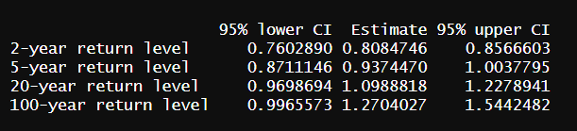

*Table W: POT parameter estimations with 95% confidence intervals.*

